SUSTAINABLE USE OF NATURAL RESOURCES-GOLD MINING IN THE LAKE ZONE: THE ALTERNATIVE VIEW
Comments on Reverend Fr. Dr. Aidan Msafiri‘s presentation at the Students Symposium on Sustainable Use of Natural Resources- Gold mining in the Lake Zone on the 24th October, 2014 at the Library Hall, SAUT Mwanza

By: Bituro Paschal Kazeri
Information Officer Tanzanian Association of Sociologists

Contact: tasaja@tasaja.org
biturokazeri@yahoo.com
P.O. BOX 2825
MWANZA
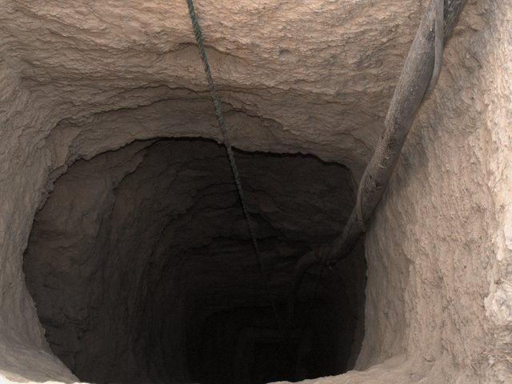
THE MINE
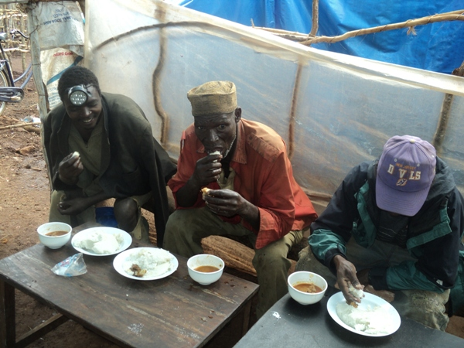
SMALL SCALE MINERS HAVING THEIR MEAL
Source: Mohamed Dewji blog

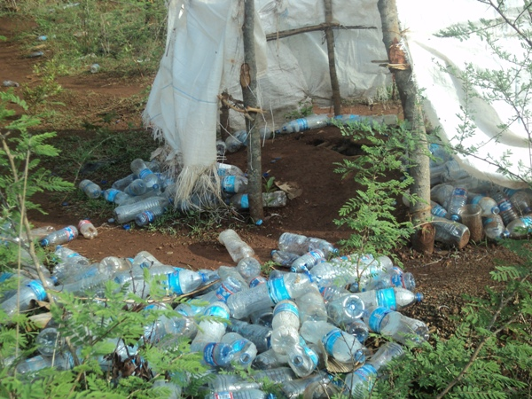
MAKE SHIFT TOILET FOR MINERS
Source: Mohamed Dewji blog

THE EFFECT OF CHEMICAL ON THE MINERS HANDS
Source: Harper

INTRODUCTION
Sociologists do subscribe to the five promises of Sociology namely: public enlightment; challenging public perception; identifying social problem; designing solution to identified social problem; and sociological imagination (C.W. Mill, 1916-1962). The scholarly, data and fact enriched and well presented presentation by a renowned scholar with massive expertise in environment and ethical issues Reverend Fr. Dr, Aidan Msafiri to a larger extent presents the views of the public towards natural recourses which in few words can be described as a curse (resource curse) instead of being a blessing; besides being a day light robbery.
These few subsequent comment are based on the promises of sociology and are inclined to provide deeper insight and may be the alternative view where it will be demanded.
CASE STUDY
Let us preface ourselves with a remarkable case study from South Africa.
Bafokeng is a small tribe in South Africa of around 150,000 (300,000 if it include these in Zimbabwe) people that for a long time have occupied an area of around 1,200 square kilometers north west of Johannesburg. Underneath their dwellings, shrubs, grazing land, and arable land, sits the world’s largest deposit of platinum.
The area was invaded by whites who displaced the indigenous. When the Bafokeng were displaced their King dispatched the brightest young men to work in diamond mines in order to earn money with it they could buy back their land.
Meanwhile in 1925 mineral explores discovered the platinum and started mining it in 1960s; the Bafokeng had repossessed their land and were in the long legal battle for gaining the mineral right. They got it in 1999 through the court of law. The loyalty they earned from the mineral rights was converted into shares. As of now Bafokeng as tribe owns 13.2 percent stake in the Impala Platinum, the world’s second largest platinum miner on top of getting 22 percent of loyalty.
Bafokeng is guided by Vision 2020 that challenges the Bafokeng people to reduce their dependency on their diminishing mineral assets and to become a self-sufficient community within the first 20 years of this century, whilst also maintaining the Bafokeng culture.

The main areas of emphasis of Vision 2020 fall into the following areas: Investment diversification; Economic Development; Education Planning; Infrastructure Development/Master Plan; Health and Social Planning; and Crime Free Environment.

The Bafokeng has established a sovereign wealth fund, Royal Bafokeng Holdings (RBH), which is responsible for overseeing the growth and maintenance of the community’s income streams. RBH has invested royalties and dividends in a number of projects, and in civic administration and social services. These include: Royal Bafokeng Sports, which is in charge of sport development among the residents of the area; Royal Bafokeng Administration (RBA), which is principally a town planning unit charged with service delivery and monitoring the progress of the Master Plan across all the regions. And Royal Bafokeng Institute (RBI), whose goal is to improve education and learning in the Royal Bafokeng Nation. Bafokeng have also recruited several manufacturing companies as part of a drive to expand the nation's exports beyond raw materials.

The gaining of the mineral rights was the first step and probably the easiest one. The second step was to ensure sustainability: What does the Loyal queen mother say:-
“I keep telling the women of the Nation: if we spend all the money what will happen? What will happen tomorrow? Platinum is not our wealth, our wealth is through leadership”
The third step was to make everyone see it that he or she is benefiting from the fight for regaining the land and subsequent mineral rights as well as the communal investment that made to day:
- Bafokeng the wealthiest tribe in Africa
- Bafokeng public rise their expectation to live a lavish life style
- Public to put pressure for swift and more distribution of wealth to individuals
The loyal king provides the leadership where he says:
“We are facing a challenging situation. The expectations are bigger and bigger. All we have to do is ask people to exercise constraint, but this is hard to sell to people with high expectation. (Russell, 2009: 157-180).
From the above case study we can have some few question to help us find answers to the issues of sustainability that are always overlooked.
Issues no. one: The mineral right
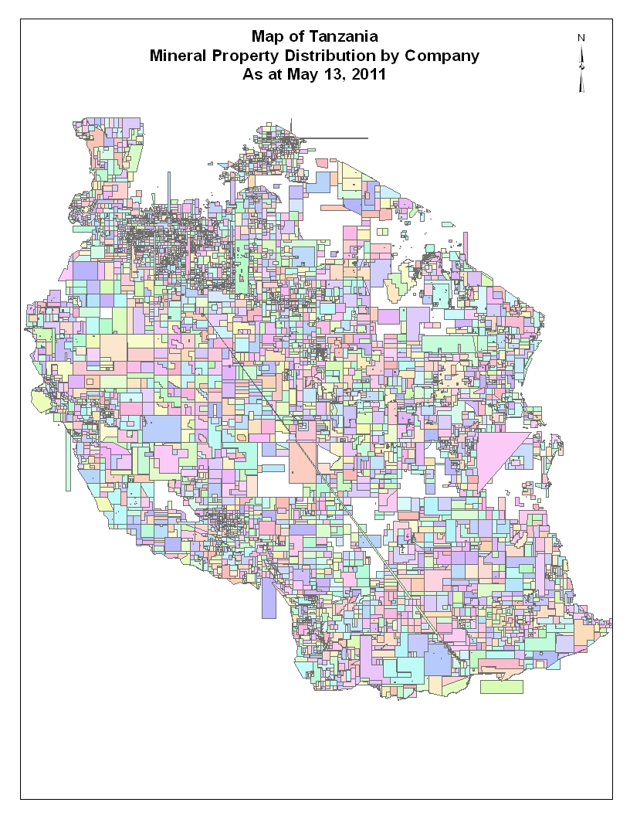
SOURCE: Ministry of Energy and Mineral (2011)

What are the principles guiding it?
In sociological views, it should be guided by three principles namely moral, social, and legal principles. In our case the legal principle is the only one leading the show, hence the problem.
Issue no. two: the exploitation
What are the principles guiding the exploitation of mineral resources. From ethical point of view, there are several principles namely:
Utilitarianism- high benefit and to the majority
Anthropocentrism- human centered at the expenses of other creations
Ecocentrism- natures centred- do not disturb.
Ecofeminism- Mother Nature, respect women rights.
Deep ecology-equitable and sustainable exploitation of resources
Speciesism- accord right to some species at the expenses of others
Consumerism- profit driven exploitation of resources
The views of the public are influenced by bombardment from the believers of one of these principles, and for sure none of the principles can stand on its own and lead us to the sustainable exploitation of natural resources. The outcome is a wagon of mess.
Issue no three: The distribution of the proceeding/ benefit
Equal benefit is the driving word but it is misleading the public. The word is equity- equity distribution of the proceedings. It is the human effort on the resources that puts values in it. When values get sold only those who applied their effort can morally, socially and legal claim a stake in the proceedings. This view also evokes the theory of natural justice (John Locke, 1632- 1704 & Karl Marx, 1818- 1883).
Issue no four: Sustainability
Extractive resources by nature are not sustainable. So why do we bring the issue up? The answer is that we have ways of converting the unsustainable sustainable. How is that possible?
One: ecologically
Nature and now the market cycles can increase and decrease the demand of extractive resources.
Two: Technologically
Advancement in technology is leading to maximization of extraction of values resulting into effective use of little amount for maximum use meaning less extraction of extractive resources
Three: investment
Investment of proceeding from extractive resources is a clear way of realizing sustainability.
Four: human resource development
Investing the proceeding from extractive resources towards human resources education and welfare ensures sustainability.

THE HISTORY MINING AND GOLD MINING IN TANZANIA AND THE LAKE ZONE
Chachage (1995), Keeler (2009), and Government of Tanganyika (1955) advance that mining was undertaken in Tanzania well before the coming of foreigners. Tanzanians mined salt for cooking and currency, clay for pottery, iron ore for tools and arms, gems for jewelry, stone and lime for construction.
During the German rule mica was mined for explosive and gold for currency. Under the German more minerals were discovered and mines in different places were opened such at Sekenke (1909), Lupa, Chunya, and in the lake zone at Negoti, Kilimafeza, Maji moto, and Geita.
There were also the discovery of diamond at Mabuki and later Kizumbi. Between 1922 and 1952 about 19,000 people 18,000 of them being African were employed in the mining sector and were responsible for generation of income of about GBP 29.9 million (GOT, 1955)
The mining sector was affected by the WWI and WWII, trade embargo on German as a punishment for starting the war, low price in the world market, and mineral right disputes.
Tanzanians who were employed in the mining sector were laid off because of the disruption. Those laid off workers converted themselves into an authorized small scale miners exploiting their knowledge of the industry (Chachage, 1995; Cooksey, 2011 &, Keeler, 2009).
In the 1990s, this entrepreneurship spirit expressed by individuals Tanzanians were massively derailed and affected by the coming of big mining companies which exploited the legal regime to their advantages at the expenses of the small scale miners who operated without mineral right.
However there is nothing to write about in respect of the small scales miners serve for the subsistence living; and turning Kenya into the world market of Tanzanian gold they smuggled there. The other remarkable highlight is the failure of the Bank of Tanzania (BOT) gold buying scheme supposedly established to create the internal market for small scale miners who instead of taking to BOT real gold they sold the fake gold. The scheme died leaving a big loss. We went back to square one.

MINING TOLL ON ENVIRONMENT SUSTAINABILITY
Displacement of the indigenous
Disruption of nature
Depletion of resources
Erosion of peace
Growing of hatrage against the government
Death
Erosion of trust to work together for the common good
Environment degradation

THE CHECKS AND BALANCES
Losing land rights, obtaining (some) compensation
Mining companies planning major investments are obliged by law to undertake detailed Social and Environmental Impact Assessments (SEIA) as a precondition for obtaining mining licenses. They also have to present an Environmental Management Plan (EMP). Environmental Impact Assessments (EIA) are the subject of Guidelines and Procedures issued by the National Environmental Management Council (NEMC).
Does it work- the case study
In the case of its Geita Gold Mine, Ashanti Goldfields drafted an Environmental Impact Statement (EIS) in 1999, the year it signed its MDA, based on reported consultations with residents of affected villages. The EIS consultants’ report to Ashanti reads in part: ‘There has not been widespread opposition to the relocation provided acceptable compensation is given for houses and crops lost by the development.’ Geita Gold Mine paid over USD 5m to a government account for resettlement of 1,800 villagers from Mtakuja ward. The money never reached the 857 people who were entitled for compensation. Apparently, the lists [of beneficiaries] contained fake names, while people who were actually living in the village were never registered.’ The Prevention of Corruption Bureau investigated claims of corruption, and two GGM employees and a number of civil servants were found guilty (Cooksey, 2011).

WHERE DID WE GO WRONG

“Nyerere felt that these same principles should be used as the basis of the government of Tanganyika so that the wealth of the country would benefit everyone in the country. He knew that Tanganyika had great mineral wealth. There are very large deposits of iron and coal in southern Tanganyika. At this period of their development, the people of the country were not capable of developing these resources.
He felt it was better to let them remained undeveloped until the time Tanzania would be developed enough and could exploit these resources rather than allow large foreign companies come and exploit this wealth for themselves while they paid only minimal wages to the Tanganyikan workers.” (Fr. Wille, the reflection on Nyerere).

“We were novices in this industry and too many companies came at once. We were overwhelmed. We still need double the capacity we have now. This sector is a big challenge to us because it has grown too fast.” Peter Dalali Kafumu Quoted (Curtis and Lissu, 2008:34) (Cooksey, 2011)

OUR MISTAKE NO ONE
Violation of God’s ordinance- You shall work on the resources to get your needs first and wants later. Before the coming of foreigners we were doing right but later things have changed. We mine gold to sell; apparently the market is not here, is not us; it is the foreigners- the world market. We are vulnerable and the sustainability is compromised. Mwalimu Nyerere may have stopped all the mining activities but stopped at the Williamson Diamond Limited mines at Mwadui! Why? Was he bribed? Was he a msanii? Was he ignorant? Was he morally, spiritually, and socially corrupt?
Wrong education: there are so many definition of education. Mine is simple
EDUCATION = ENVIRONMENT + WORK+ TIME.
Our education is based on how long (time) one have stayed in the classrooms away from the environment doing nothing but copying others work in the name of references. Because of this approach while we claim to have a lot of mineral deposit few people selected to study geology; yet more few selected to study mining engineering; and again very very few studied mining economy, law, and contract negotiation. What did they select to study? Law, accounting, material management, ete etc
Deniability
The world is ruled by the powerful who are supported by big corporate in exchange for protection. Fighting them is possible but the first step is to acknowledge their presence and use their way to fight them like the Bafokeng did.
On the other hand deniability is manifested in the non disclosure. Seventy (70) of the mineral right is owned by Tanzanians. I know none of them who have come forward and raised a finger to say I am enjoying the resources of the land. Indeed, keeping quiet is a form of corruption. But there is no secret under the sun. Cooksey (2011) helps us to know:
Wilson Mutagwaba, a mining engineer, was quoted as saying: ”not many people know that 70 per cent of licenses are in the hands of locals. The problem ... is that most of their owners are hawkers and middlemen waiting to sell them for a quick buck.”…. For example, Barrick bought the mining rights of Buzwagi from Madaba Minerals Ltd, who receive (d) a retainer until mining begins, after which Madaba will receive/ receives a percentage of gold sales (Business and Politics interview I)( Cooksey, 2011)

The Game theory
We are made to fight each other for the benefit of these who are not involved in the fight.
There are fights between Local and foreigners; small and big miners; activists and the ruling elites; environmentalist and non- environmentalist. All these battles are paid for by big corporate as the strategy to weaken and character assassinate the opponents. For example Norway has supported study to vilify the gold mining sector but it is not so aggressively involved in the oil and gas issues where the Norway firms are involved. Why?
The deep pocket doctrine
It pays to support the weak in their fight against the strong and vice versa. Politically you gain popularity if you stand for the weak instead of the strong, irrespective of other factors. The struggle for mineral right over Bulyankulu mines presents a good case. This how it unfolded
AGENT | FOR SMALL MINERS | FOR BIG COMPANY-SUTTON FROM CANADA
State house | President Mwinyi | President Mkapa
Political parties | CCM, Oppositions
Minister –mineral | Minister Kassam | Minister Kikwete, Shija
Local politician | Bikhu Mohamed Salehe & Julius Manyambo
Judiciary | High Court | Court Of Appeal
Diplomat |  | Canadian High Commissioner
Security and police |  | RPC,FFU, DC,RC
Gold trader | Local and International
Aid agencies |  | World Bank, MIGA
Civil societies | LEAT, Amnesty International
Media

Source: Cooksey, 2011

SOLUTION
Solution one- work
Solution two- be part of the game
Keeler (2007) gives us the direction where he writes:
“These measures, if passed, would be on top of revisions already made in 2007 under which Barrick, AGA and Resolute agreed to pay annual levies of USD 200,000 to local authorities. The companies also gave up their 15% tax allowance on unredeemed capital, which means they will start paying income tax sooner, probably within the next few years. Barrick also agreed to a “voluntary” contribution of USD7m a year to the government for five years. The Ministry of Energy and Minerals is expected to present a fully revised Mining Act by the end of the year, which is supposedly almost complete. Bomani also recommended raising the metals royalty rate from 3 to 5%, and that the government should take a 10% stake in all mining operations in the country. These government shares would be managed by the State Mining Corporation (STAMICO).”

Have we tried to implement this?

The Mining Act of 2010 directs that the government of Tanzania shall acquire 10 percent free carried interest in any mine that is and will be developed in Tanzania (sect 10, Mining Act, 2010) The ACT define free carried interest as:

“Free carried interest” means the interest derived from holding shares of which the holder enjoys all the rights of a shareholder but has no obligation to subscribe or contribute equity capital for the shares;”

Solution three- create the local market for our own resources
Solution four-equity
Solutions five- acknowledge and respect other players
Solution six- limit dependency on minerals through diversification

CONCLUSION
Resources sustainability is a cross cutting issue that needs to be objectively addressed in order to send a clear message to the public. As it is now, the public is denied the correct information the fact that compromise their discourse and decision making. There is a need to encourage each one of us to think and see the big picture at the individual level, then at the collective level and use these understanding to make adequate and appropriate policy, legal and institution frameworks. Your Turn is the right forum for individual to express their inner views. Let us exploit it to the possible maximum. The Tanzanian Association of Sociologists joins hands with others to thank the organizers (KAS and CETA) for this opportunity where people will shares their concerns over the issues of environment sustainability resulting from the direct hit from the mining activities in the lake zone and beyond. Thank you.

References
Chachage, S.L. (1995). ‘The Meek Shall Inherit the Earth but Not the Mining Rights’, Peter, G. (ed.) Liberalised Development in Tanzania, Nordiska Afrikainstitutet, Uppsala
Cooksey, B (2011) The investment and Business Environment for Gold Exploration and Mining in Tanzania, London, African Power and Political Programme
Corporate Guide International Ltd & Tanzania Investment Centre (2011) Corporate Tanzania: The Business, Trade and Investment Guide 2010/2011

Curtis, M, and Lissu, T, (2008) A Golden Opportunity: How Tanzania is failing to benefit from gold mining, Christian Council of Tanzania, National Council of Muslims in Tanzania and Tanzania Episcopal Conference
Kazeri, B. (2009, April 19) ‘Do Tanzanians know the truth on mining?’, Guardian Weekend Review, Dar es Salaam, 19 April

Keeler, R. (2009) Tanzania Mining Industry: Revenues, Resentment and Overregulation? Ratio Magazine
Russell, A. (2009) After Mandela: The Battle for the Soul of South Africa, London, Windmill Books
Society of international Development (2009) The Extractive Resource Industry in Tanzania. Status and challenges of the Mining Sector, Nairobi, Ascent ltd
Tanzania Extractives Industries Transparency Initiative (2011) The TEITI Reconciliation of Payment made by the Extratictive Companies to the Government Final Report, Oxfordshire, Hart Group & BDO East Africa.
The Government of Tanganyika (1955) Tanganyika: A Review of its Resources and their Development, London, The Government of Tanganyika
The Mining Act (2010)
The United Republic of Tanzania (2009) The Mineral Policy of Tanzania, Dar es Salaam, Ministry of Energy and Minerals.
http://www.bafokeng.com/future/vision-2020

